I want to create a iOS coffee app similar to Vivino but just for me and my coffees.

Overview

I have reviewed special coffees for 10 years in a basic format:
- take photo of bag with my iphone
- Move to Coffees Album
- Add details to title, caption and or description
- Details are likely unstructured though usually I have all of the following data types (not all coffees have all details. Many have most though)
  - Timestamp of photo (that equals day when I bought bag)
  - Roaster Name
  - Roaster country (usually a country in europe)
  - Origin country (usually a country outside europe)
  - Origin farm
  - Altitude of crop or farm
  - Roasting type
  - Roasting date (not very relevant, most don’t have it)
  - Price (convert all currency to euro)
  - Rating (it’s in the form of <rating>/5 - for example 4.1/5; 3,9/5)
  - Description, usually semi structured around: Farm/lot/coffee description, Brew guide, Roaster description
  - Weight (in g) - most would be one of: 100g, 200g, 250g
- I will provide exhaustive fixed lists for each data type
- Guess only very close matches and prompt me to validate anything else
- When data is missing try to OCR photo and add to same data structure
- I will want to filter sort by all data above plus have text search looking in all data (structured or not) for each

Parseing
For parseing historical data plus monthly check new entries I want the simplest and fastest and most secure option. Likely that is using shortcuts / automation, either on iphone or mac
Keep in mind that there’s usually a 4-5 days gap between taking the photos of new coffee bags and adding description
I need to understand effort and token costs of moving coffee adding in the iOS app (taking photo and entering details) vs continuing with iCloud Photos as it’s now.

When parseing text or OCR use an estimate of accuracy for identified structured data and trigger a manual review when it falls under threshold.

Always use alternative names, consider misspellings, deduct country by city mentioned (example - a roastery is from Amsterdam => country is Netherlands)
Deduct altitude by pattern - usually it’s shown as a range likely between 900 and 2200 usually less than 200 apart ( (“1300 ro 1600”)and measured in masl (meters above see level) or m (meters). Unify and only use m.

Numbers will vary in format from 4.1 to4,1 to 1.600 to 1,600 etc

Price is mostly in lei or euro so it should be easy to deduct as currency is likely present

Weight is in grams shown as g, gr, grams or similar

In general unify all formatting and measuring units for all extracted structured data.

Farm is sometimes referenced as producer.

I want 3 different ai agents extracting data and cross validating. No hurry,this is critical, and it only happens once in the beginning so we need to make sure accuracy is top.

UI

Listing page
  - List of coffees each row with
    - Photo
    - month and Year bought format July 2026
    - Roaster name + roaster country flag
    - Origin farm + Origin country flag
    - Roasting profile - color coded tag with icon
    - Rating in the format “⭐️4.1”
    - Favorite icon
    - Price with an additional Price per 100g
  - Top filters cards for things like 4.5 stars, Anaerobic, Cofermented. Max 7 cards, horizontal scroll, add to the examples top 4 origin countries by count of coffees with rating 4 or more. Add card with favorites
  - Filter (each value has number of items counter - example: <Ethiopia (12) >)
    - Year taken from Timestamp of photo
    - Favorites
    - Roaster
    - Roaster country
    - Origin country (usually a country outside europe)
    - Origin farm
    - Altitude ranges (ranges of 500m)
    - Roasting type
    - Price range (ranges of 5 euros)
    - Rating in ranges of 3-3.5, 3.5-4, 4-4.5,4.5-5
  - Sort by
    - Date bought
    - Rating
    - Price

Coffee page
    - Clicking any coffee takes to Coffee page
    - Photo + structured data nicely formatted
    - All the rest of description, structured where possible Farm/lot/coffee description, Brew guide, Roaster description, roaster logo
    - Rows with horizontal scrolll with 4-5 items each plus More where needed
      - Other coffees from <roaster name>
      - Other coffees from <origin country>
      - Other coffees roasted <roasting profile>
      - clocking more leads to listing page with appropriate filter

Insights page
- Insights list with short text with Correlations between rating and all other structured data
    - Trends charts with yearly counts of
      - Origin Countries
      - Roasting profile
      - Roaster

Roaster page
logo, short description ( static text), website URL, tags with number of coffees, average rating

Under it list of coffees with filtered by roaster

You only get to this page by clicking the flag in a coffee page

Origin country page
flag, short overview (static text), tags with number of coffees, average rating

Under it list of coffees with filtered by origin country

You only get to this page by clicking the flag in a coffee page

sample UI from Vivino

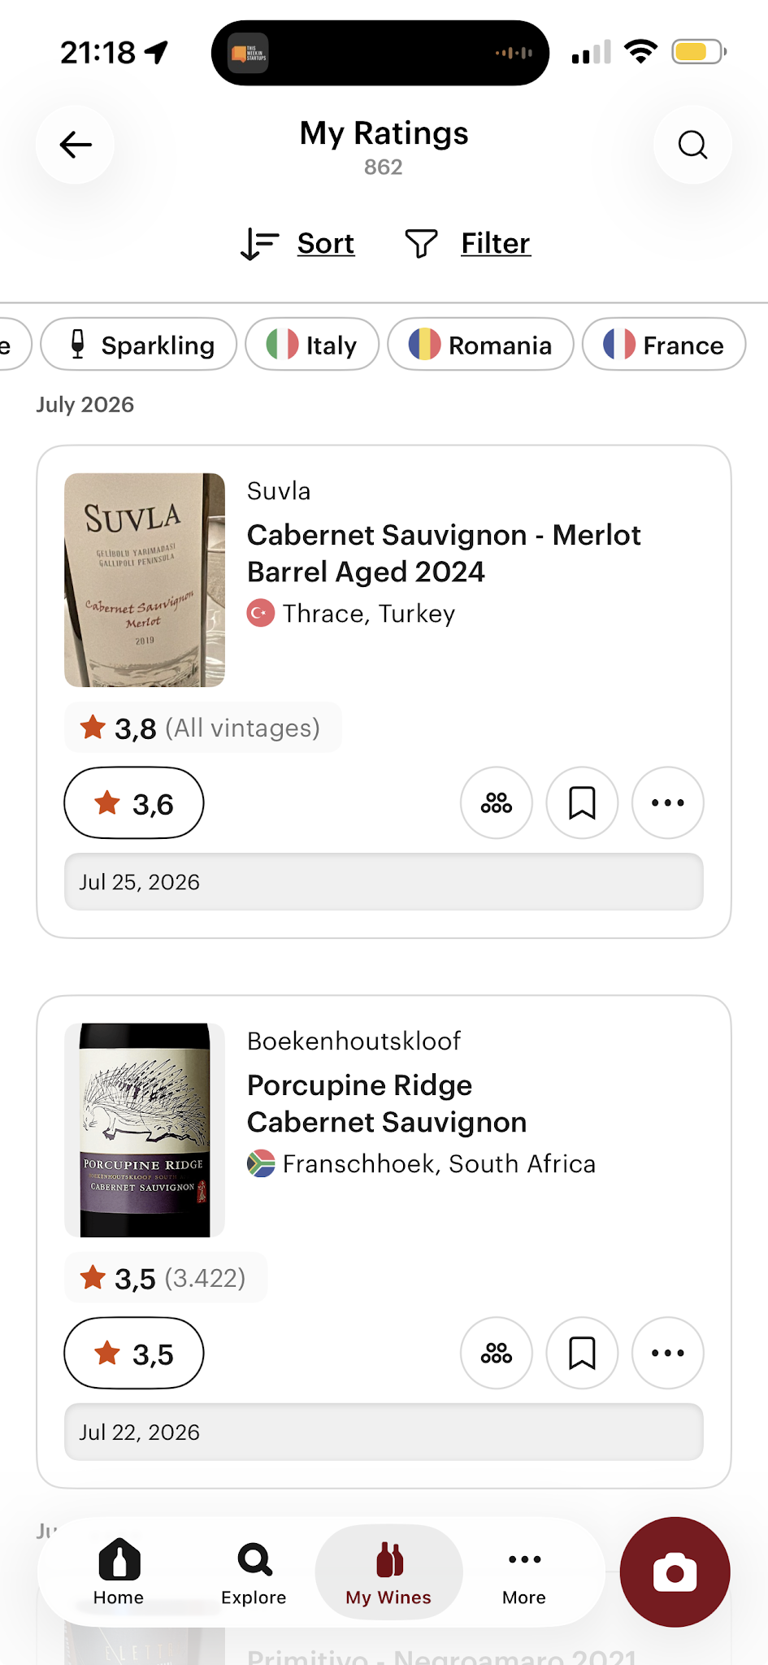

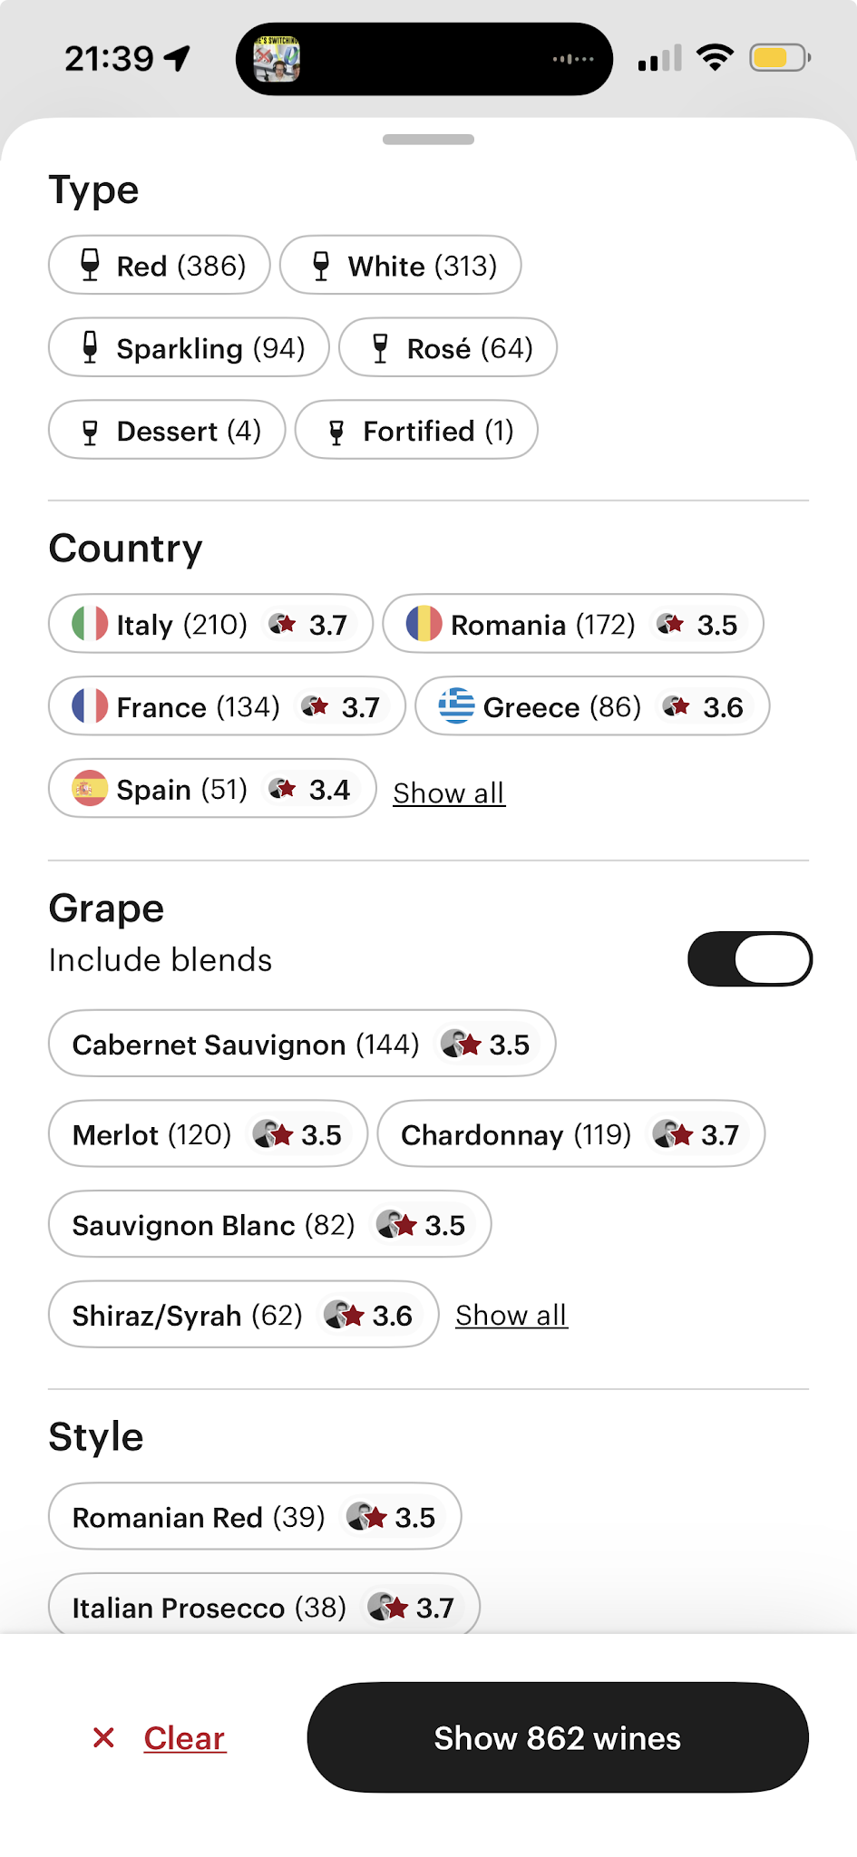

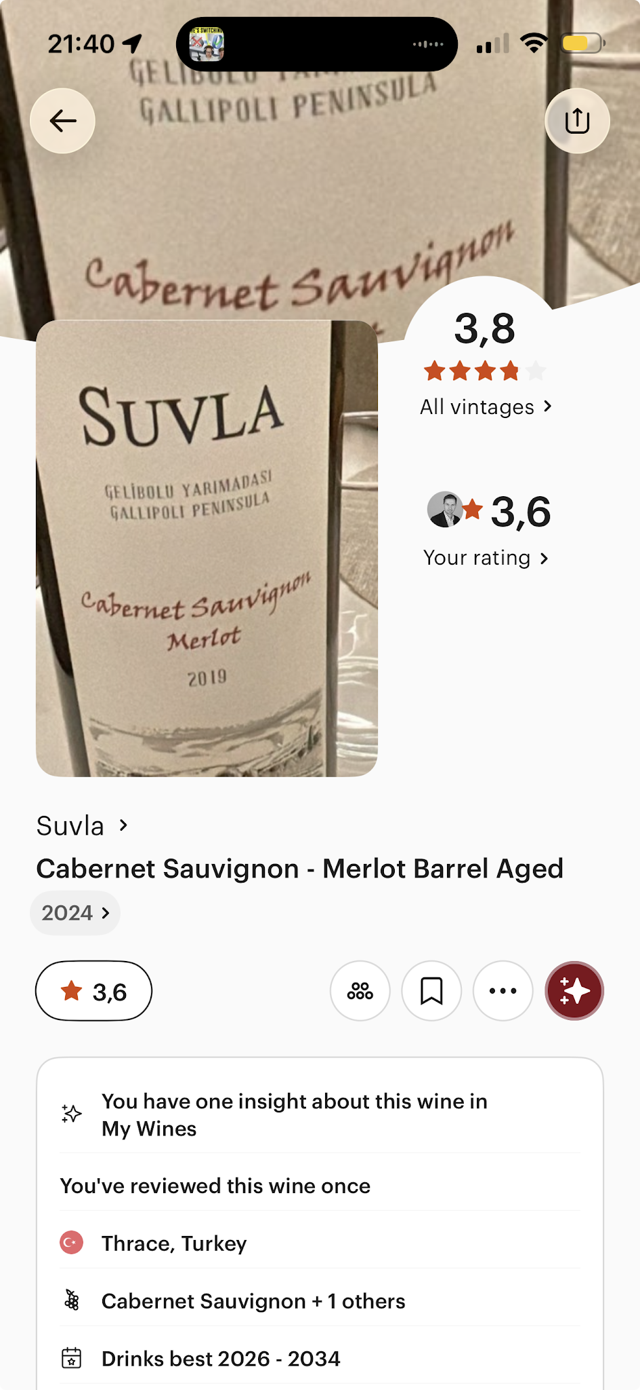

Roasting profile
Decaf
Natural
Washed
Anaerobic
Co-fermented
Experimental

Ideally i want ALL coffees allocated to one of these. If coffees have more detailed roasting profiles to be shown entirely on coffee page, but for filtering / sorting / insights i need all to have one of these values.

Roasters list (not exclusive, some duplicates in list, needs dedupe)
DAK Coffee Roasters (24)
The naughty dog (34)
The Coffee Collective (4)
People Possession (4)
Father's Coffee Roastery (13)
Doubleshot (5)
Coffea Circulor (8)
BirdSong Coffee (4)
Beansmith.s (3)
Fiftybeans (5)
Rocket Bean Roastery (3)
Nordbeans (4)
Concept Coffee Roasters (8)
The Barn (8)
Coffeein (2)
Candycane Coffee (8)
Manhattan Coffee Roasters (4)
Nomad Coffee (1)
Dos Mundos (2)
Rebelbean (4)
Tribes of Mokha Roastery (4)
Square Mile (3)
Sprout Coffee Roasters (3)
Poppy Beans (6)
HAYB Speciality Coffee (6)
Respekt Coffee (3)
Not Another Boring Roastery (3)
Mia Coffee Roastery (9)
Boo! (7)
Tao Coffee (1)
Kofio (1)
Tanat Coffee (2)
Kaffa (7)
Blind Monkey (1)
Gust. Specialty Coffee (6)
Roastlab coffee roasters (5)
Lot Roastery (6)
Krok (3)
Oh My Bean Roastery (11)
Kmen Coffee Roasters (10)
September Coffee (3)
Typika (1)
Hydrangea Coffee Roasters (2)
Punkt. coffee (1)
Industra Coffee (6)
Beansmith's
(2)
Guido
(9)
Keen Coffee
(8)
Maggma Beans
(7)
Man vs Machine
(7)
Momos Coffee
(1)
Radical Coffee
(9)
Right Side
(5)
Siemasu
(1)
A.M.O.C
(18)
Ahiya Roasters
(8)
Aliena
(6)
April
(13)
Bani Beans
(14)
Bonanza
(4)
BOO Modern Coffee
(4)
Brewing Dealers
(42)
CandyCane
(5)
Coffea Circulor
(30)
Concept Coffee Roasters
(40)
DAK
(117)
Doubleshot
(4)
Drop Coffee Roaster
(8)
Elbgold
(7)
Father Carpenter
(4)
Father's
(12)
Fjord
(7)
Friedhats
(57)
FRUKT
(3)
Gardelli
(33)
Goat Story
(3)
Goriffee
(12)
GroundState
(5)
Gust Coffee
(4)
Jonas Reindl
(3)
Kawa
(27)
Kolibri
(3)
La Cabra
(22)
Legendary Everyday
(6)
Mabo
(13)
Manhattan
(12)
Nero Scuro
(3)
NOMAD
(13)
Nowhere
(10)
ONYX
(13)
People Possession
(42)
Process Coffee
(11)
RightSide
(25)
Roastery 29
(14)
Rumbaba
(9)
RushRush
(3)
Sloane
(22)
Sprout Coffee Roaster
(13)
Sumo Coffee Roasters
(10)
Swerl
(4)
Tanat
(25)
The Barn
(28)
Three Marks Coffee
(4)
Tim Wendelboe
(25)
Uncommon

Roasters Countries list (not exclusive, some duplicates in list, needs dedupe)
Ethiopia (75)
Kenya (13)
Rwanda (8)
Colombia (83)
Brazil (38)
Bolivia (5)
Burundi (8)
Costa Rica (16)
Ecuador (4)
El Salvador (2)
Guatemala (11)
Indonesia (4)
Mexico (3)
Nicaragua (2)
Panama (2)
Papua New Guinea (1)
Peru (11)
Tanzania (2)
Uganda (6)
Venezuela (1)
Vietnam (1)
Yemen (1)

Origin Countries list (not exclusive, some duplicates in list, needs dedupe)
Belgium (13)
Czech Republic (146)
Denmark (4)
France (6)
Germany (8)
Ireland (1)
Canada (3)
Latvia (3)
Netherlands (31)
Norway (8)
Poland (6)
Slovakia (23)
Spain (1)
United States (2)
United Kingdom (3)

Romania

Brazil
(3)
China
(1)
Colombia
(6)
Colombia / Brazilia
(1)
Etiopia
(3)
Mexic
(1)
Blend
(3)
Bolivia
(7)
Brazilia
(61)
Burundi
(10)
Columbia
(314)
Costa Rica
(45)
Ecuador
(14)
El Salvador
(31)
Ethiopia
(164)
Guatemala
(36)
Honduras
(28)
Indonezia
(14)
Kenya
(35)
Mexico
(2)
NIcaragua
(10)
Panama
(11)
Peru
(37)
Rwanda
(39)
Tanzania
(3)
Thailanda
(1)
Uganda
(9)
Vietnam
(2)
Yemen

